The following water quality report is presented to the citizens of the City of Auburn using information provided by the Barrow County water and sewerage authority and from Gwinnett County water authority, also from testing in and around the City of Auburn. Should you have any questions regarding the information in this report, you may contact Elbert Blackstock, Auburn’s public water licensed operator at (770)963-4002. This report details information on our water system for the calendar year of 2023, January 1st to December 31st
During the calendar year of 2023 the City of Auburn purchased 96% of our drinking water from Barrow County Water and sewer Authority (BCWSA).
We purchased 4% of our water from Gwinnett County as needed.

City Of Auburn
Water System ID # 0130000

Inorganic contaminants |  | Date | Units | MCL | MCLG | Detected | Above Advisable level | Major sources |  | Violations
Fluoride |  | Daily | PPM | 4.0 | 4.0 | 0.81 PPM Average | 0 | Erosion of Natural deposits Water additive that promotes strong teeth |  | No
Turbidity |  | Daily | NTU | .300 | .300 in 95% of samples | 0.013 NTU average | 0 | Soil runoff |  | No
Chlorine |  | Daily | PPM | 4.0 | 4.0 | 0.70 PPM  Average | 0 |  | No
  Added to water
  as a disinfectant

Total Trihalomethanes | Quarterly | PPb | 80 | 80 | 84 | 0 PPB | Byproduct of water disinfection with chlorine | yes
Total Haloacetic acids | Quartey | PPb | 60 | 60 | 56 | 0 | By-product of drinking  Water chlorination. | No

Lead | 2022 | PPB | AL 15 | 0 | 0 | 0 | Corrosion of Household Plumbing systems , erosion of Natural deposits | NO
Copper | 2022 | PPb | AL 1300 | 1300 | 26 | 0 | Corrosion of household plumbing system, erosion of natural deposits | NO
Microbiological | Monthly | Positive /Absent | 5%of Monthly Samples  May be positive | N/A | 0 | 0 | Naturally present in environment | No

(Total Trihalomethanes (TTHM) Some people who drink water containing trihalomethanes in excess of the MCL over many years may experience problems with their liver, kidneys, or central nervous systems, and may have an increased risk of getting cancer. Violation Type Violation Begin Violation End Violation Explanation MCL, LRAA 01/01/2023 03/31/2023 Water samples showed that the amount of this contaminant in our drinking water was above its standard (called a maximum contaminant level and abbreviated MCL) for the period indicated. 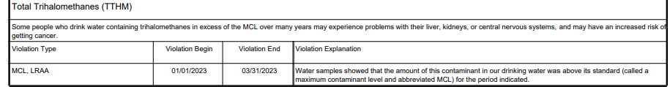

Table Key
AL = Action Level | Water-Quality Table Footnotes
MCL = Maximum Contaminant Level | 1. ppb of lead reported as the 90th percentile of samples taken
MRDL = Maximum Residual Disinfectant Level | 2. ppb of copper reported as the 90th percentile of samples taken
MCLG = Maximum Contaminant Level Goal
MRDLG = Maximum Residual Disinfectant Level | 3. Turbidity is a measure of the cloudiness in water. We monitor turbidity because it is a good indicator of the effectiveness of our filtration system.
ppm = parts per million or milligrams per liter (mg/L)
ppb = parts per billion or micrograms per liter (ug/L)
p/a = presence/absence (microbial)

The Barrow County Water System is pleased to present a summary of the quality of water provided to you during the past year. The Safe Drinking Water Act (SDWA) requires that utilities issue an annual "Consumer Confidence" report to its customers. This report details where our water comes from, what it contains, and the risks our water testing and treatment are designed to prevent. Barrow County Water System is committed to providing you with the safest and most reliable water supply. Informed consumers are our best allies in maintaining safe drinking water. We encourage public interest and participation in our community’s decisions affecting our drinking water. The Barrow County Board of Commissioners meets each month on the second and fourth Tuesday at 6:00 pm in the Commission Meeting Room located on the second floor of the Historic Courthouse, 30 North Broad Street in Winder, GA. Any comments are welcomed; please contact our office at 770-307-3014. Water Source: Barrow County purchased all of its drinking water from the Upper Oconee Basin Water Authority. The water supply sources for the Upper Oconee Basin Water Authority are Bear Creek and the Middle Oconee River. How to Read this Table The chart in this report provides representative analytical results of water samples, collected in 2023 unless otherwise noted from the Barrow County Water System. Please note the following definitions: Maximum Contaminant Level or MCL: The highest level of a contaminant that is allowed in drinking water. MCLs are set as close to the MCLGs as feasible using the best available treatment technology. Maximum Contaminant Level Goal or MCLG: The level of contaminant in drinking water below, which there is no known or expected risk to health. MCLGs allow for a margin of safety. Action Level: The concentration of a contaminant, which triggers treatment or other requirement, which a water system must follow.
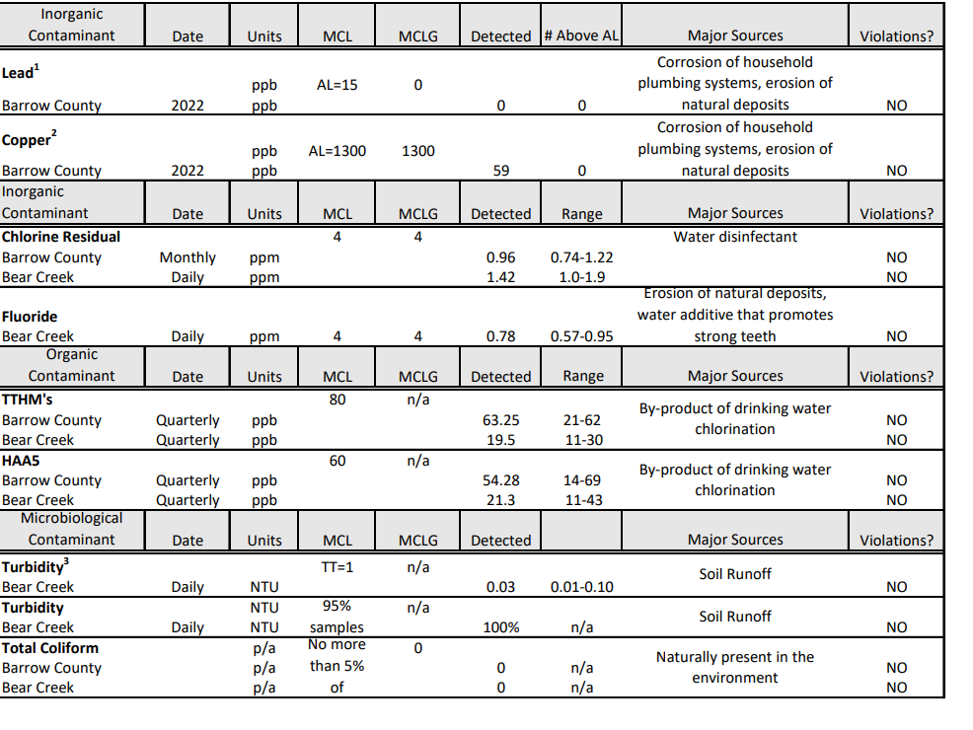
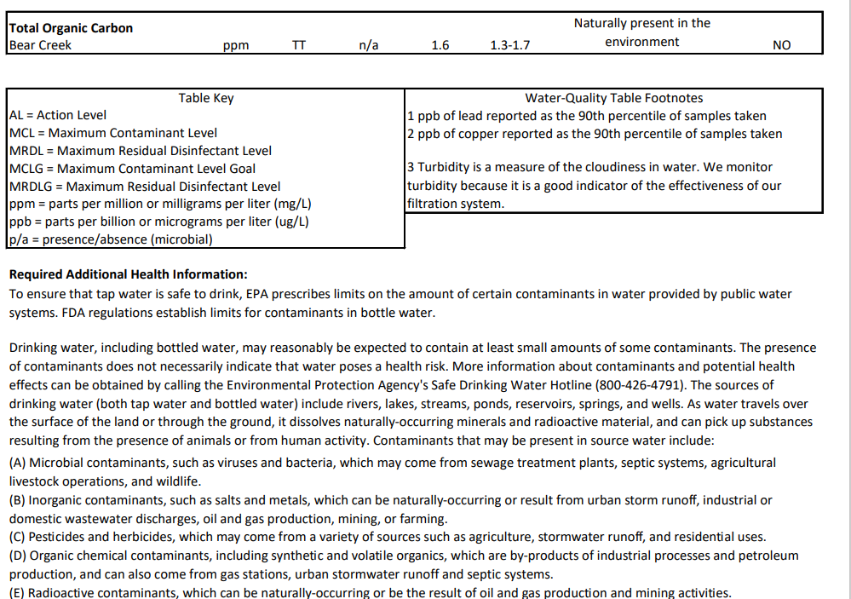
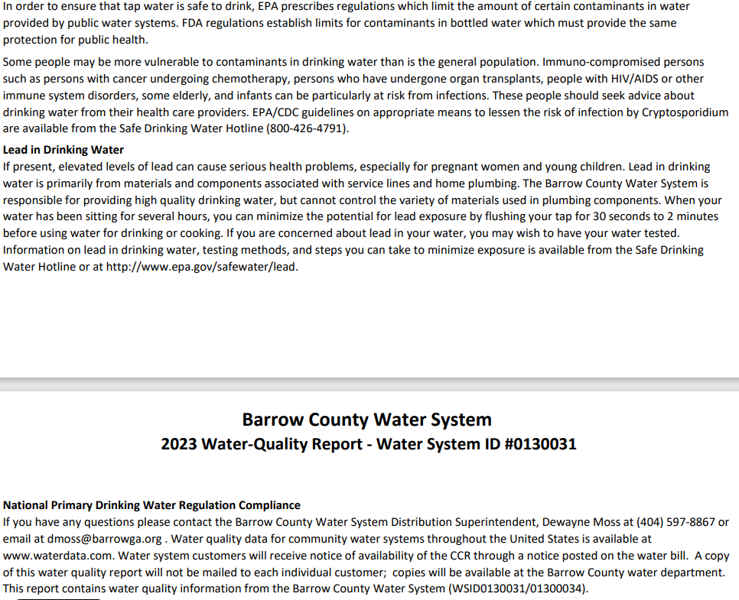
Gwinnett County Data

