WhistleStop Shops  Market  Day  10AM-6PM  July 22nd  1369 4th Avenue Auburn, GA 30011 | 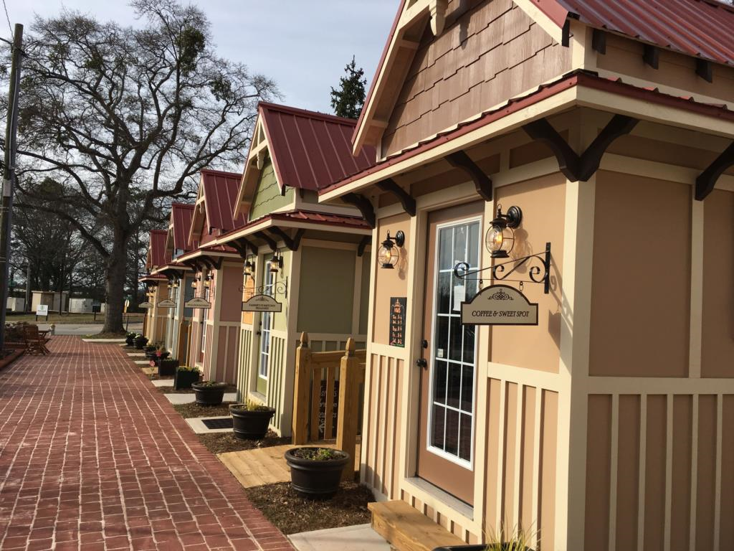
Food Trucks  - Kids Zone  - Live Entertainment  - Prizes  - Juried Vendors | Petals Children’s Boutique  Team Sports Apparel  Dragonfly Dreams  Tammie’s Hometown Treasures  Coffee & Sweet Spot  Tiffany’s on the Corner  Shimmer  Willotta’s Pastry  Burgundy’s Ice Cream & More  Wanderlust Boutique  Burgundy’s Ice Cream & More  Team Sports Apparel

